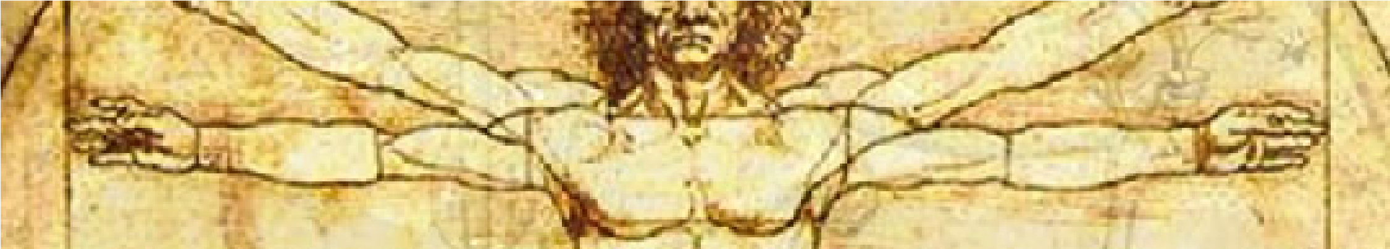
Medical Anatomy & Physiology 2021/2022

Contact Information
Elizabeth Moretz  Room 1201 |  | Elizabeth.Moretz@slcschools.org  Google Voice: (385)323-0775

Course Description
Medical Anatomy and Physiology (MAP) considers the interrelationships between structure of the human body, the function of these structures, and the biological processes that are essential for proper function of the human body. This course will provide students with an in-depth instruction of anatomy, physiology, medical terminology, diseases and disorders, medical ethics, and first aid. Students will participate in a variety of lab activities and dissections, field trips, class discussions, projects, and readings to provide a hands-on, student-centered, active learning experience. This class is designed to prepare students for advanced health science courses and health technology programs.

Learning Objectives
- Recognize and discuss human anatomical structures and their corresponding functions.
- Understand physiological processes and their importance in maintaining a healthy organism.
- Apply understanding of anatomical structures and physiological processes to notable diseases and disorders.
- Develop connections between anatomical structures, physiological processes, and the maintenance of homeostasis.
- Integrate appropriate terminology and apply rigorous scientific processes to evaluate and discuss real-world applications of medical issues.
- Demonstrate effective laboratory skills in evaluating anatomical structures and physiological processes.

Materials
- Lab journal (provided by instructor)  - Readings (provided by instructor) | - Index cards  - Pen/pencil & colored pencils  - Lab appropriate clothing (on lab days)

Course Work & Evaluations
Medical Anatomy & Physiology will consist of a variety of activities. Success in the class will be determined by successful participation and completion of the following:

- Labs & activities (including dissections)
- Maintenance of lab journal
- Readings
- Class discussions & guest speakers
- Quizzes, tests, and lab practicals
- Projects
- Field trips

Classroom Expectations
All students are expected to participate fully, to the best of their ability, in all class activities. This includes class discussions, lab experiments and dissections, field trips, projects, maintenance of a lab journal, and other class assignments. Every class member is expected to treat every class member, course materials and specimens, and class guests with the utmost respect. Honesty and integrity is expected of everyone; failure to maintain an honest work ethic will result in disciplinary action.

Scope and Sequence
Introduction to the Human Body |  | Anatomical terminology
 |  | Homeostasis & Biochemistry
 |  | Cellular organization
 |  | Tissue organization
Integumentary System |  | Structure, function, development, & aging
Skeletal System |  | Bone structure, function, development, & aging
 |  | Axial skeleton
 |  | Appendicular skeleton
 |  | Joints
Muscular System |  | Muscular tissue structure
 |  | Muscular system movement
Nervous System |  | Nervous tissue & signaling
 |  | Spinal cord & spinal nerves
 |  | Brain & cranial nerves
 |  | Autonomic nervous system
 |  | Sensory, motor, & integrative systems
 |  | Senses
Endocrine System |  | Endocrine structure, function, development, & aging
Reproductive System |  | Male & female reproductive structure
 |  | Human reproduction
 |  | Development & inheritance
Cardiovascular System |  | Blood structure & function
 |  | Heart structure & function
 |  | Blood vessels & circulation
Respiratory System |  | Respiratory structure, function, development, & aging
Lymphatic System |  | Lymphatic structure & development
 |  | Immunity
Urinary System |  | Urinary structure, function, development, & aging
 |  | Fluid, electrolyte, & acid-base homeostasis
Digestive System |  | Digestive structure, function, development, & aging
 |  | Metabolism & nutrition

STUDENTS & PARENTS/GUARDIANS: PLEASE ACKNOWLEDGE THAT YOU HAVE REVIEWED THIS COURSE DICSCLOSURE AND PROVIDE ADDITIONAL INFORMATION BY COMPLETING THE ACKNOWLEDGEMENT FORM ON CANVAS (“course disclosure form” assignment)

